**Supporting Information**

# Temperature-Feedback Two-Photon Responsive Metal-Organic Frameworks for Efficient Photothermal Therapy

**Reagents and materials**

All starting materials were obtained from commercial supplies and used without further purification. The chemicals of trimesic acid, triethylamine, hexadecyl trimethyl ammonium bromide (CTAB), copper nitrate trihydrate (Cu(NO3)2) and gold(III) chloride hydrate (HAuCl4) were purchased from Aladdin Co., Ltd. The chemicals of sodium borohydride (NaBH4), silver nitrate (AgNO3), ascorbic acid (AA) and 1-tetradecamol (PCM) were purchased from Macklin Co., Ltd. (4,5-dimethylthiazol-2-yl)-2,5-diphenyltetrazolium bromide (MTT) was obtained from Beyotime Biotech Co., Ltd. (China). Calcein AM/PI Kit and Annexin V-FITC/PI Apoptosis Detection Kit was obtained from Shanghai Bestbio (China). Ultrapure water was used throughout.

**Apparatus**

UV-vis absorption spectra were recorded on a UV-265 spectrophotometer. SEM was detected by REGULUS8230*. TEM was carried on a JEM-2100. The 1H NMR spectra recorded on at 25℃, using Bruker 400/600 Ultrashield spectrometer were reported as parts per million (ppm) from TMS (δ). PXRD patterns were recorded on SmartLab 9KW. Fluorescence measurements were performed on a Hitachi F-7000 fluorescence spectrophotometer. One-photon and two-photon imaging data acquisition and processing were performed using Lecia TCS SP8 DIVE FALCON which equipped with single-wavelength laser and femtosecond laser (adjustable output wavelength: 680-1080 nm, 80 MHz, 140 fs).

**Measurement of photothermal performance**

**AMPP** aqueous solution (2 mL) with different concentrations (50, 100 and 150 µg/mL) and water as control were placed under the 900 nm laser irradiation (1 W/cm2) for 10 min, respectively. Subsequently, **AMPP** aqueous solution (150 µg/mL) with different laser power intensity (0.8, 1 and 1.2 W/cm2) were exposed under the 900 nm laser irradiation for 10 min, respectively. The temperature changes in this process are recorded by a NIR camera.

$θ=\frac{T-T_{sur}}{T_{max}-T_{sur}}$ (1)

$t=τ_{s}×(-㏑θ)$ (2)

$hS=\frac{(∑miCp，i)}{τ_{s}}$ (3)

$Q_{Dis}=hS×({T(H_{2}O)}_{max}-T_{sur})$ (4)

$η=\frac{hS×\left(T_{max}-T_{sur}\right)-Q_{Dis}}{I×(1-{10}^{-A_{900}})}$ (5)

Where Tmax is the final temperature, Tsur is the temperature of the environment, h is the thermal conductivity, S is the surface area of the quartz cuvette walls, QDis is the lost energy of the laser, I is the laser energy of 1 W/cm2, and A900 nm is the UV-vis absorbance of **AMPP** (150 μg/mL) at 900 nm.

**Electron spin resonance (ESR) assay**

The spin traps 5,5-dimethyl-1-pyrroline-N-oxide (DMPO, trapping •OH, 20 μL) were employed to detect the species of ROS generated by **AMPP** (150 μg/mL). The ESR signal of **AMPP** was recorded before and after LED light irradiation.

**Programmed Release of PyS**

After **AMPP** was treated at 37°C and 42°C for different times (0, 4, 8, 12, 16, 20, and 24 h), the **AMPP** solution was centrifuged and the drug release of **AMPP** was assessed by measuring the UV-vis absorbance of the supernatants at 500 nm.

**ROS Detection**

According to our previous work, **MOF-199** displayed chemotherapy through Fenton-like reaction triggered by its disintegrated in an acidic environment. [1] In addition, temperature has been proved having significant effects on the catalytic activity of Fenton-like reactions. Therefore, the synergistic effect of temperature with Fenton-like reaction was further studied using methylene blue (MB) as an indicator of •OH. As demonstrated in Figure S9, the absorption band decreased when interact with •OH, and the descend range markedly increased under light irradiation, indicating that the increased temperature induced by light can actually improve the generation efficiency of •OH. Moreover, electron spin resonance (ESR) trapping measurements were further carried out to verify the generation of •OH, in which 5,5-dimethyl-1-pyrroline-N-oxide (DMPO) was used as trapping agent. Characteristic signals of DMPO-OOH (1:2:2:1 triplet, g = 2.003) were observed in a mixture of **AMPP** and H2O2, indicating the production of •OH (Figure S10).

**Cellular uptake analysis**

Hep G2 cells were seeded onto the cell culture dishes and grown to about 70% confluency for next using. Hep G2 cells were treated with **AMPP** (150 μg/mL). After 6 h incubation, the cellular uptake capacity of **AMPP** was analyzed using CLSM.

**Cytotoxicity assays in cells**

The PTT/CDT effect of **AMPP** was studied by the methylthiazolyldiphenyltetrazolium bromide (MTT) assay. The **AMPP** stock solution is diluted with fresh medium to the required concentration (0, 50, 100, 150, 200, 250 μg/mL). Before the experiment, Hep G2 cells were cultured for 24 h in 96-well plates. Then exchange the cell culture medium with different concentrations of **AMPP** medium solution. They were incubated at 37°C for 8 h in 5% CO2 atmosphere, and then irradiated by laser (900 nm, 1 W/cm2) for 10 min. 100 μL of fresh medium were used to exchange the cell medium solutions 20 μL (5 mg/mL) MTT solution were added to each well following. The cell plates were then incubated for another 4 h. After removing the MTT medium, the formazan crystals were dissolved in DMSO (100 μL/well) and the absorbance was detected at 490 nm using a microplate reader. And duplicated experiments have been tested.

**Live/Dead assay with calcein AM/PI**

After the Hep G2 cells were washed with PBS solution twice, **AMPP** (150 μg/mL) was added to the above medium and incubated for 6 h, and then the cells were treated under different conditions. calcein-AM/PI (1 µM) were added to detect the cells vitality of Hep G2 cells. Fluorescence images were collected by CLSM.

**Determination of Annexin V-FITC and PI**

Hep G2 cells were incubated with **AMPP** (150 μg/mL) at 35°C and 5% CO2 for 6 h. Add H2O2 (100 µM) and laser (900 nm, 1 W/cm2) irradiation for 10 min, respectively. Then, the Annexin V-FITC (1 μM) and PI (1 μM) were added and incubated for 20 min. Fluorescence images of the cells were collected by a confocal laser scanning microscope.

**Flow Cytometry Study**

Cells seeded into the 6-well plates were incubated for 24 h, the medium containing **AMPP** (150 μg/mL) was used. After irradiated with laser (900 nm, 1 W/cm2) for 10 min, the cells were collected after centrifugation and then resuspended in binding buffer containing propidium iodide (PI, 10 μL) and annexin-V FITC (5 μL) for 15 min in darkness. The signal was collected by a BD FACS Calibur flow cytometer (Beckaman/Gallios).

**Culture of 3D multicellular tumor spheroids (3D MCTs)**

5 mL Poly HEMA solution was added to 25 mL cell culture flask, ethanol was evaporated at 37℃ and sterilized for 3-5 h under ultraviolet lamp. The culture flask was cleaned with PBS twice and 1 mL of tumor cell mother liquor was added. When the cell mass density is relatively high, flask processing is performed, and the cells are further cultured for 3-5 days, allowing for the formation of 3D multicellular spheroids with appropriate diameters. 3D MCTs were incubated with **AMPP** (150 μg/mL) for 5 h. Then, 3D MCTs stained with calcein AM and PI for 15 min, then washed with PBS solution and analyzed by CLSM.

**Animal model**

All the animal procedures were approved by the Institutional Animal Care and Use Committee of Anhui University (serial number: 2020-042) based on the National Standard of China GB/T35892-2018 guidelines for Ethical Review of Experimental Animal Welfare. We have taken great efforts to reduce the number of animals and tried to reduce animal suffering from pain and discomfort. Female BALB/C mouse was used for antitumor test in vivo, and to avoid immune stress response, H22 cells were chosen for animal experiments. Female BALB/C mouse subcutaneously injected with 0.1 mL cell suspension containing 5×105 H22 cells. When the tumor size was about 100 mm3, the mice was treated via intravenous injection with **AMPP** (5 mg/kg).

**Hemolysis Assay**

The mouse red blood cells (RBCs) were obtained by removing serum from the blood by centrifugation and washing. Then RBCs were suspended in phosphate-buffered saline (PBS) was mixed with **AMPP** at a final concentration of 10, 20, 30, 50 and 100 μg/mL. RBCs in PBS solution and DI water were set as the negative control and the positive control, respectively. After the mixtures were incubated at 37 °C for 2 h and centrifugated for 5 min, the absorbance at 450 nm of these supernatants was measured using a microplate reader. The hemolysis percentage was calculated using the following formula:

$$Hemolysis ratio \left(\%\right)=\frac{A_{sample}-A_{negative}}{A_{positive}-A_{negative}}*100\%$$

A: absorbance at 450 nm.

**In vivo fluorescence imaging performance of MIrA**

Female BALB/C mice bearing H22 tumor received intravenous injections of **AMPP** solution (5 mg/kg). To evaluate fluorescence imaging performance, images were obtained at 0, 2, 4, 6, 8, 10, 12, 24 h post-injection along with corresponding fluorescence signal. And then, the corresponding mice were sacrificed humanely and their major tissues and tumors were obtained and imaged by a small animal imaging system.

**In vivo therapeutic assessment**

BALB/C female mice with H22 tumor were randomly divided into four groups (n = 5): Control, NIR laser (900 nm, 0.1 W/cm2, 5 min), **AMPP** and **AMPP**+NIR laser (900 nm, 0.1 W/cm2, 5 min). Corresponding amount of **AMPP** (5 mg/kg) were intravenous injected into the mice. The mice weight and tumor size were recorded every two days. The mice were humanely sacrificed after 14 days for histopathological analysis.

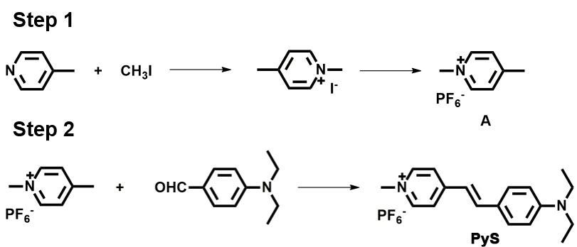

**Figure S1.** The synthesis routes of probe **PyS**.

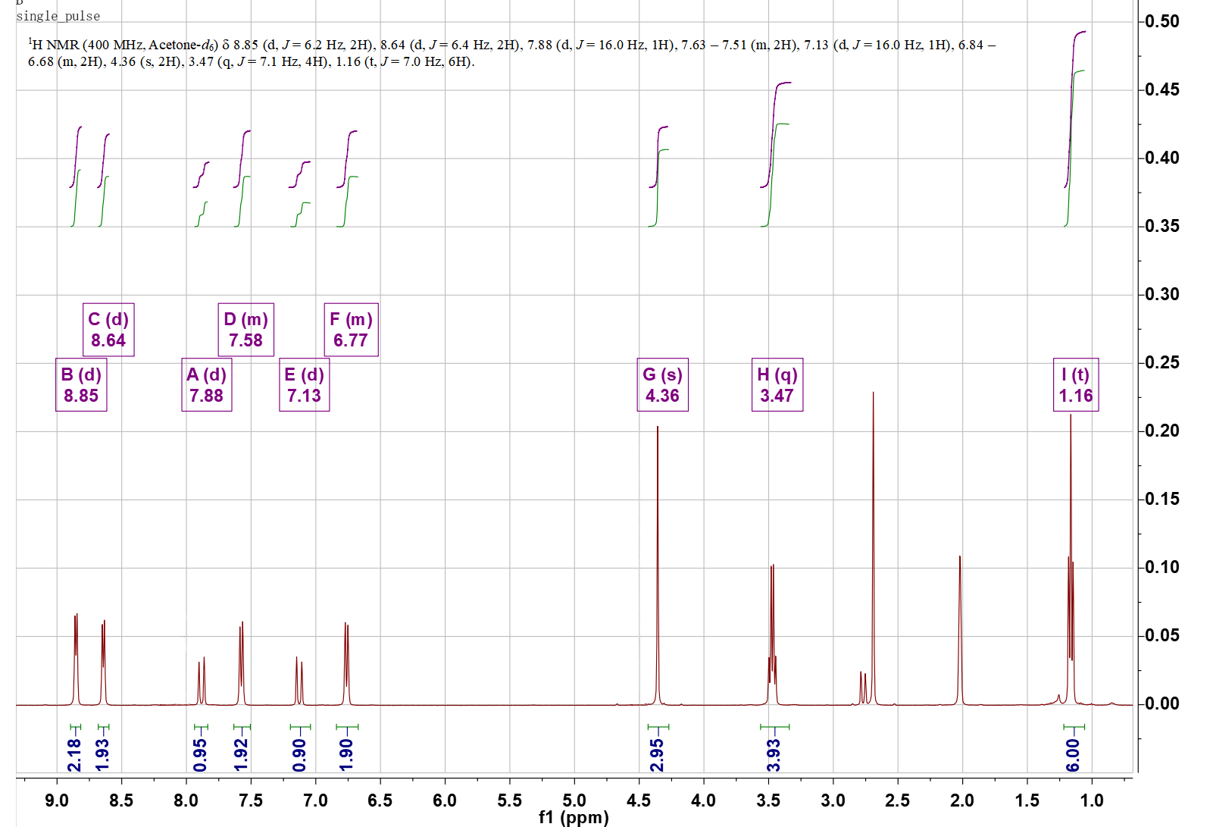

**Figure S2.** The 1H NMR spectrum of **PyS** (400 MHz, acetone-*d6*, r.t.).

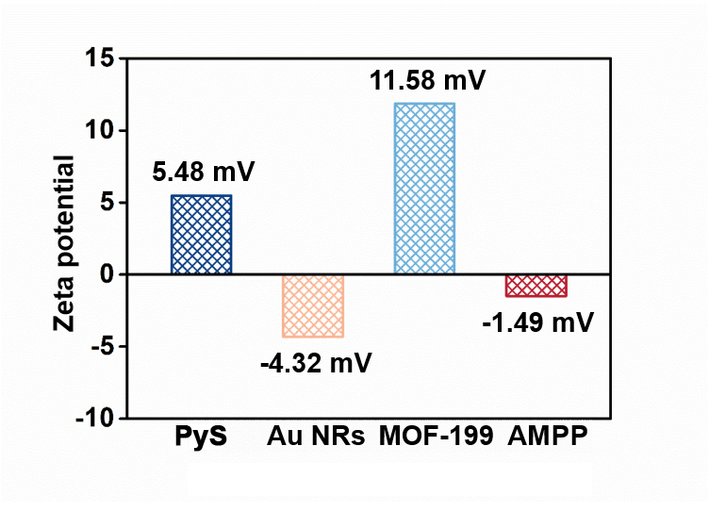

**Figure S3.** Zeta potentials of **PyS**, **Au NRs**, **MOF-199** and **AMPP**.

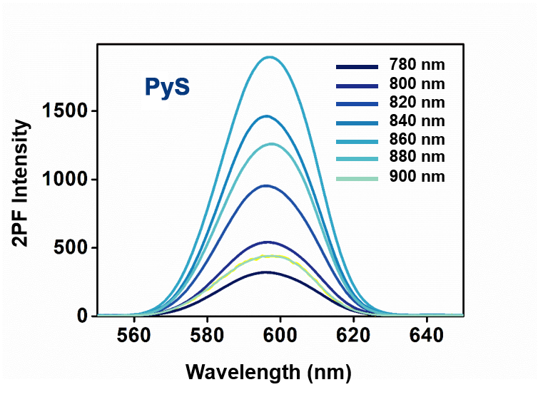

**Figure S4.** The two-photon fluorescence spectrum of **PyS** (concentration: 1 mM; solvent: DMSO; wavelength: 780-900 nm).

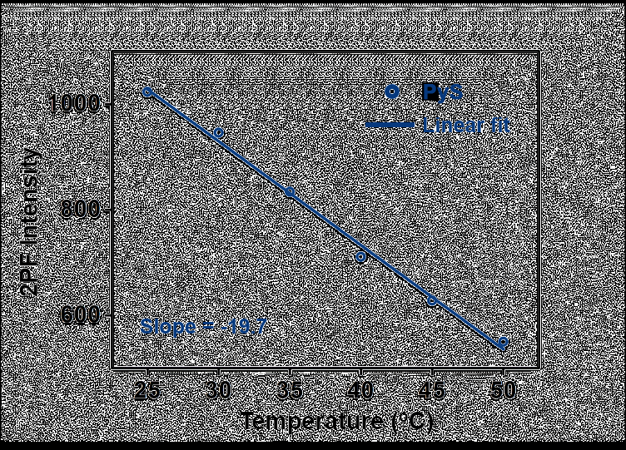

**Figure S5.** The relationship of two-photon fluorescence intensity and temperature of **PyS**.

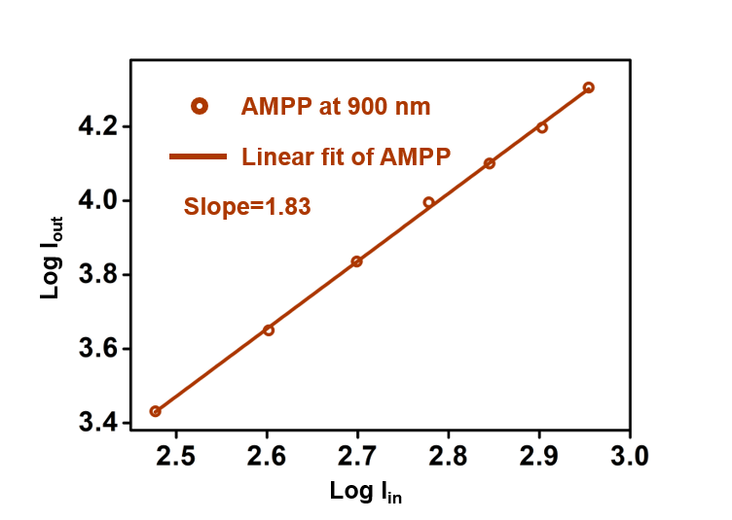

**Figure S6.** Two-photon excited fluorescence verification of **AMPP** at 900 nm.

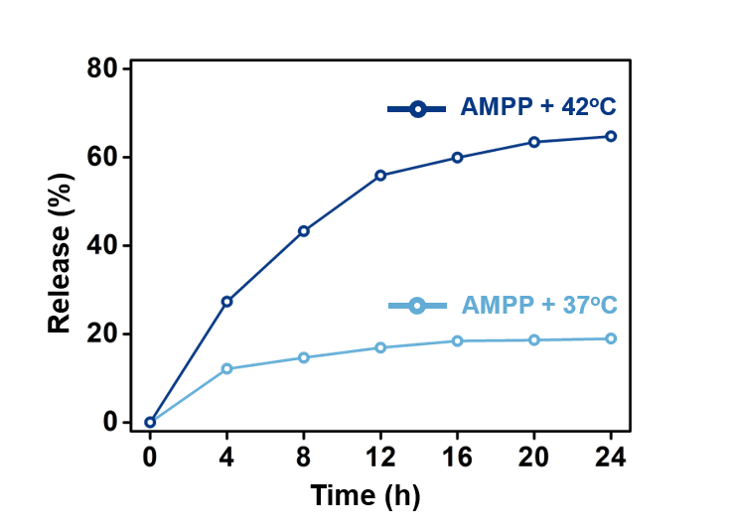

**Figure S7.** Comparison of releasing ability of **PyS** in **AMPP** under 37°C and 42°C, respectively.

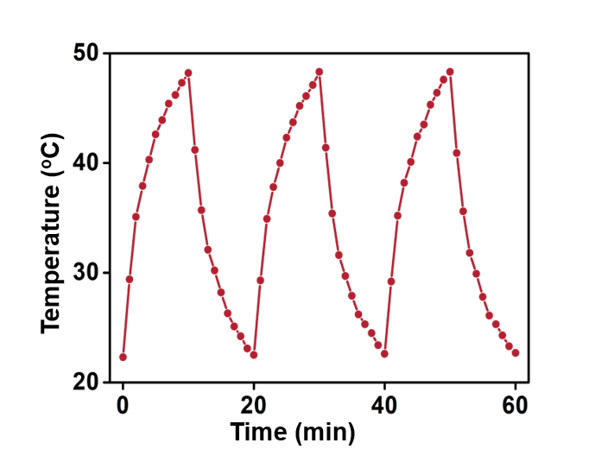

**Figure S8.** Temperature curves of **AMPP** under continuous NIR laser irradiations for three cycles (900 nm, 0.1 W/cm2).

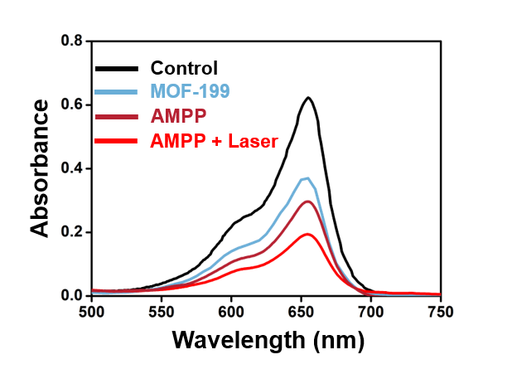

**Figure S9.** MB degradation with **AMPP** under different circumstances.

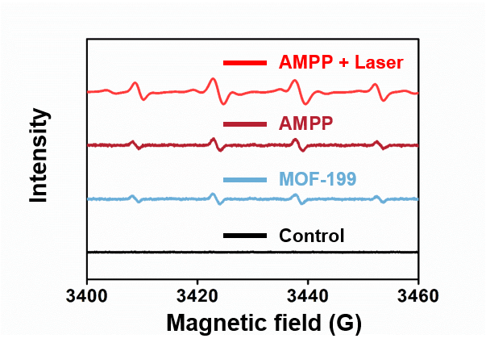

**Figure S10.** ESR signals of **AMPP** trapped by DMPO under different circumstances.

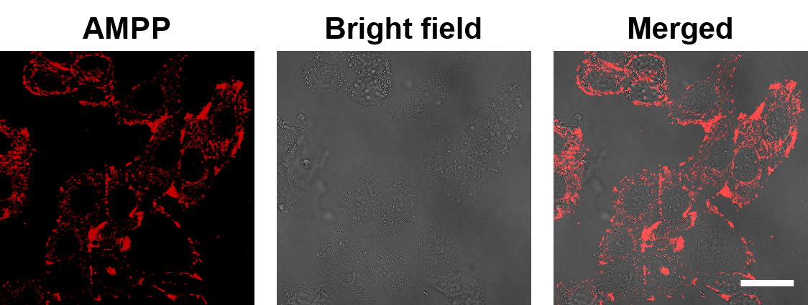

**Figure S11.** CLSM images of Hep G2 cells incubated with **AMPP** (150 μg/mL). Scale bar: 20 μm.

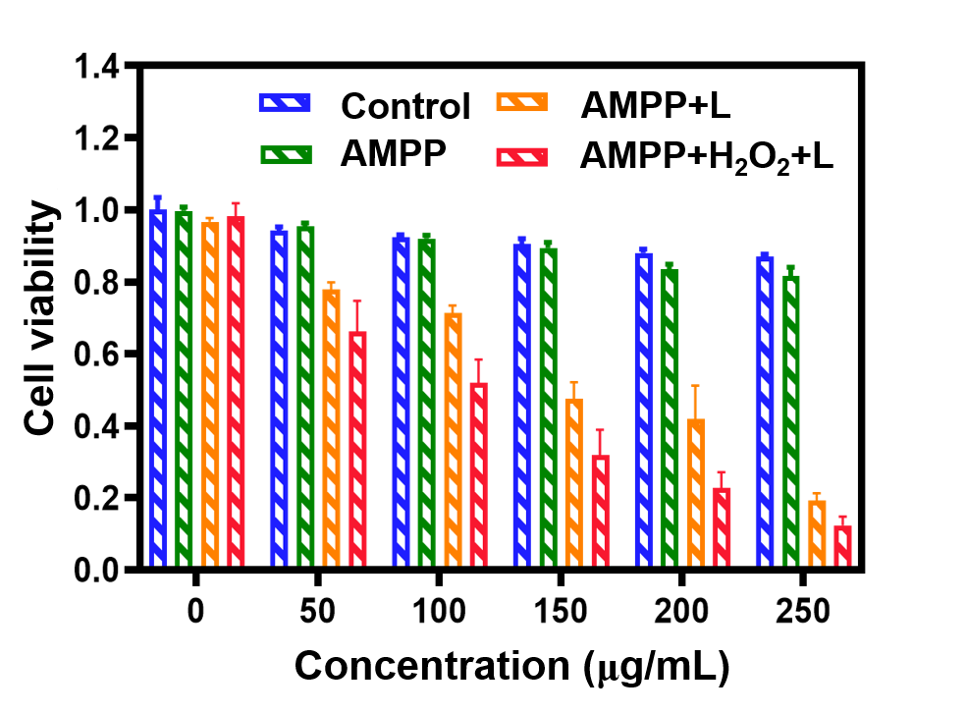

**Figure S12.** Cell viability for different concentrations of **AMPP** with different conditions.

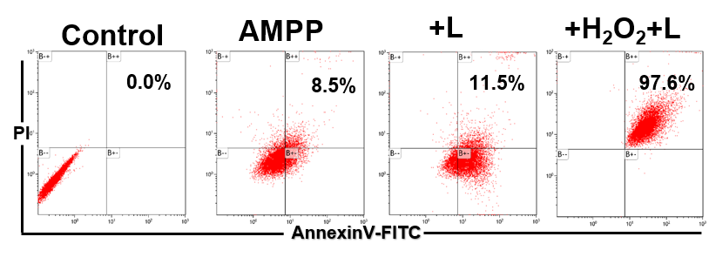

**Figure S13.** Flow cytometry apoptosis assay of Hep G2 cells stained with Annexin V-FITC/PI after being treated with different conditions.

REFERENCE

[1] Yao, X.; Pei, X. X.; Li, B.; Lv, M. Q.; Zhang, W.; Ni, B.; Zhang, Q.; Tian, Y. P.; Xu, C. Z.; Li, D. D. Rational fabrication of a two-photon responsive metal-organic framework for enhanced photodynamic therapy. *Inorg. Chem. Front.*, **2021**, *8*, 5234-5239.